Lab 2 – Classifying Land based on NDVI

## Background

In 1972, NASA launched what is known today as the Landsat (Land + Satellite) program. The Landsat program is the longest continuous enterprise for the acquisition of satellite imagery of the Earth. The satellite imagery provides data for land assessment, coverage, and usage on a global scale. Landsat satellites collect images in several electromagnetic spectrum bands. These bands can be combined in various ways to create false color images and other data products. In GIS, Landsat data can be used to calculate the Normalized Difference Vegetation Index (NDVI), the measure of vegetation greenness, to identify irrigated cropland. A model for calculating NDVI can be created in ArcGIS Pro ModelBuilder by combining data from the red and near-infrared bands. A classified NDVI output map can be used to identify the locations of irrigated and non-irrigated land.

## Problem Statement

Landsat records the energy that is reflected from the Earth’s surface within the electromagnetic spectrum. According to the Global Land Cover Facility (GLCF), seven bands are recorded: red, near-infrared (NIR), green, blue, and two short wave infrared (SWIR) wavelengths (Campbell, 167).

Landsat imagery has been available since 1972. The imagery has been provided by six different satellites that have gone through the Landsat series. These satellites have been a major component of NASA's Earth observation program, with three primary sensors evolving over thirty years: MSS (Multi-spectral Scanner), TM (Thematic Mapper), and ETM+ (Enhanced Thematic Mapper Plus). Landsat satellites supply high resolution, visible, and infrared imagery. The ETM+ sensor also provides thermal imagery and panchromatic images. The Landsat data available through GLCF is designed to complement project goals of distributing a range of global, multi-temporal, multi-spectra, and multi-resolution imagery appropriate for land cover analysis.

Landsat satellite data records distinct electromagnetic wavelengths as unique bands. This allows a given location to be viewed as a separate layer in GIS. This way you can see which wavelengths are reflected more and which are reflected less for a given area. Two bands that are frequently used in earth science projects are the red (3) and the NIR (4) bands. These bands reflect differently on water, rocks, and vegetation. (Jensen, 335) This makes the features on the Earth’s surface distinguishable from each other (e.g. vegetation vs. volcanic rock). These bands are also reflected differently within vegetation itself because of chlorophyll and water content (Jensen, 334). Green vegetation absorbs red light and reflects NIR. This means that different land cover types can be identified (e.g. forest vs. sagebrush steppe).

A table of all bands and their specific ranges in the electromagnetic spectrum is given below:

<http://zulu.ssc.nasa.gov/mrsid/tutorial/Landsat%20Tutorial-V1.html>.

|  |  |  |  |  |
| --- | --- | --- | --- | --- |
| **Band** | **RBV** | **MSS** | **TM** | **ETM+** |
| **1** | 0.48-0.57 μm green |  | 0.45-0.52 μm blue | 0.45-0.52 μm blue |
| **2** | 0.58-0.68 μm red |  | 0.52-0.6 μm green | 0.52-0.61 μm green |
| **3** | 0.69-0.83 μm IR |  | 0.63-0.69 μm red | 0.63-0.69 μm red |
| **4** |  | 0.5-0.6 μm green | 0.76-0.9 μm NIR | 0.76-0.9 μm NIR |
| **5** |  | 0.6-0.7 μm red | 1.55-1.75 μm SWIR | 1.55-1.75 μm SWIR |
| **6** |  | 0.7-0.8 μm IR | 10.4-12.5 μm TIR | 10.4-12.5 μm TIR |
| **7** |  | 0.8-1.1 μm IR | 2.08-2.35 μm SWIR | 2.1-2.35 μm SWIR |
| **8** |  |  |  | 0.52-0.9 μm panchromatic |

Table 1: Landsat Instrument Bands  
:

IR = infrared

NIR = near infrared

SWIR = short wavelength infrared

TIR = thermal infrared (long infrared)

μm = micron or micrometer.

The difference in reflections of various wavelengths can be used to determine the effective “greenness” of vegetation. This is done by calculating the Normalized Difference Vegetation Index (NDVI). The NDVI is mathematically defined by Jensen, 2000, Campbell, 2008, and Lillesand, et al., 2008. (see Equation 1)

NDVI = (NIR - RED) / (NIR + RED)

Equation 1: The Normalized Difference Vegetation Index (NDVI) equation.

NDVI is a reliable vegetative index that is used in many applications. NDVI has been used to detect grub feeding on turf grass before damage became visible (Hamilton). The Idaho Department of Water Resources uses NDVI to determine evapotranspiration rates in the Eastern Snake Plain Aquifer and the Boise Valley aquifer (Kramber). NDVI is meant to find the warmest spots from the NIR band and remove any spots that contain red.

One of the practical applications of NDVI is to differentiate between irrigated cropland and non-irrigated land (Calera et al. 2001). In this exercise, you will use ArcGIS Pro ModelBuilder to calculate the NDVI and you will use Landsat data for the Utah County area to identify irrigated cropland from non-irrigated land.

## Data

Landsat Data: Download the Landsat Data from the link found on Learning Suite

ModelBuilder Tools

You will use the following new tools in this exercise along with tools from previous labs:

Float: A spatial analyst tool that converts numerical data of other types into float data. Float data is a data type that stores a floating-point number (i.e. the decimal place can move)

Plus, Minus, and Divide: Take input raster datasets and perform their respective operations.

Reclassify: Changes values in a raster. In this exercise, based on your knowledge as the researcher, you will reclassify the NDVI value to reflect non-irrigated land and irrigated land.

## Example Model

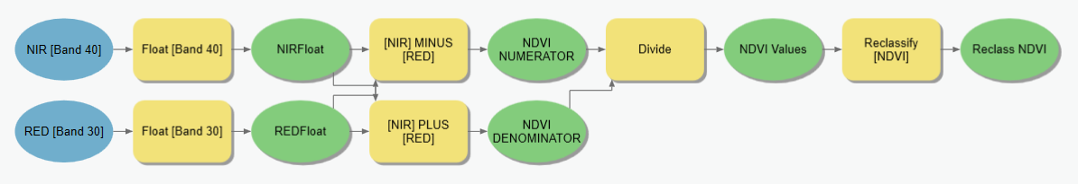

## Complete the Lab

For an advanced GIS student, the information up to this point is all you need to complete the assignment and create an output map from the results. Feel free to try conducting the analysis using only the information provided above. If you complete the lab only using the information provided above (without using the step-by-step instructions below) make sure to indicate this in your lab report to be considered for extra credit. If you need extra help, follow the step-by-step solution below. Make sure to create and screen capture an ArcGIS Toolbox Interface for your model.

For extra credit, try downloading red and infrared Landsat data for another time step or location and run your analysis again and present a second map with the new map. Use the information on this page to find new Landsat Satellite scenes: <https://landsat.usgs.gov/landsat-data-access>

## Step by Step Solution

### Step 1

Use the **Float** tool to change the data inside the raster from **Integer** type to a **Float** type for each of the input layers. The Float tool is a Spatial Analysts tool. You may need to turn on the Spatial Analyst Extension to run the tool. Click the **Project** tab, open **Licensing,** and click the **Configuring your licensing options** button. Check the box for **Spatial Analysis.**

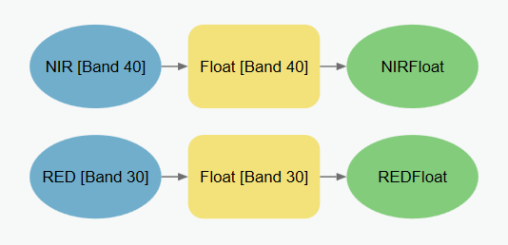

Figure 1: Using the Float tool in ModelBuilder

### Step 2

Use the **Minus**, **Plus**, and **Divide** tools to model the NDVI equation. This method allows us to first calculate the top and bottom parts of the equation separately and then divide the two parts like the NDVI equation specifies. (see Figure 2 and Figure 3)

NDVI = (NIR - RED) / (NIR + RED)

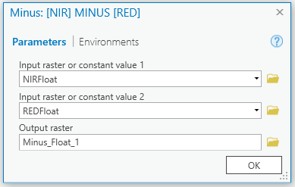 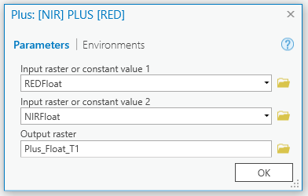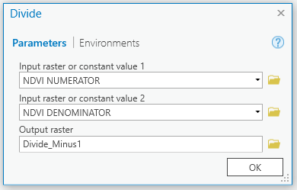

Figure 2: Minus and Divide Tool Windows

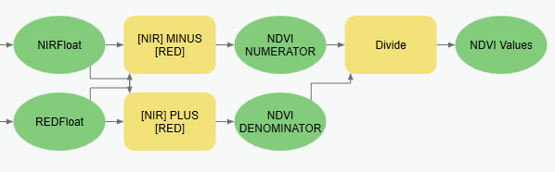

Figure 3: Minus, Plus, and Divide tools in ModelBuilder.

### Step 3

Use the **Reclassify** tool to reclassify the raster based on a pre-determined value that represents irrigated cropland. The value was determined by creating a polygon shapefile over an identified irrigated cropland area and calculating its mean. The pre-determined mean value is 0.4. Non-irrigated cropland values will be below the mean and irrigated cropland values above. Reclassify the raster based on the values given below.

Non-irrigated cropland values: -1.0 – 0.4

Irrigated cropland values: 0.4 – 1

In the **Reclassification** tool window, add or delete rows using the **Add Entry** and **Delete Entries** buttons. (see Figure 5)

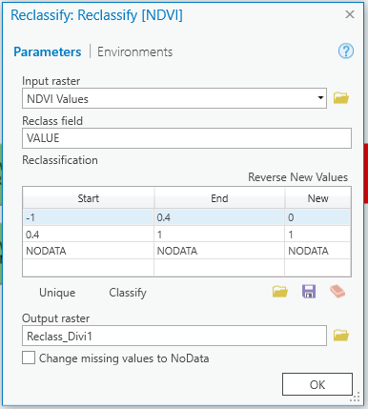

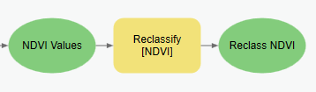

Figure 4: The Reclassify tool window used as a parameter and the ModelBuilder example

### Step 4

Use the methods shown in class to create a **Toolbox Interface for your model.** Right click the input and output data and choose the “Parameter” option. This will add a letter “P” next to those ovals on your model. Save your model (and your ArcGIS Pro project file). Open the Catalog view and find your model in your Project Toolbox. Double click the model to show its Toolbox Interface. Screen capture this interface to include in your report.

Deliverables

**Create a model** that will prepare all the input data for the land cover analysis, conduct the analysis, and **create a map** that indicates the locations of irrigated land. Include in your map several of the biggest cities in Utah County to reference where your map is located. The resulting map should show irrigated and non-irrigated lands using NDVI. Identify interesting irrigation patterns such as central pivot irrigation areas with their distinctive circular shapes. Submit a report including your **model**, **map**, and conclusions of your findings as requested in the grading rubric. Make sure to include a screen shot of your **Toolbox Interface** as well.

References

Campbell, J.A. (2008) Introduction to Remote Sensing. The Guilford Press. 465-466.

Hamilton, R.M., Foster, R.E., Gibb, T.J., Johannsen, C.J., and Santini, J.B. (2009) “Pre-visible Detection of Grub Feeding in Turfgrass using Remote Sensing.” Photogrammetric Engineering and Remote Sensing. 75. 179-191.

Jensen, J.R. (2000) Remote Sensing of the Environment An Earth Resource Perspective. Prentice Hall, Upper Saddle River, New Jersey. xii, 361-362.

Kramber, W.J., Morse, A., and Allen, R.G. (2010) “Mapping Evapotranspiration: A Remote Sensing Innovation.” Photogrammetric Engineering and Remote Sensing. 76. 6-10.

Lillesand, T.M., Kiefer, R.W., and Chipman, J.W. 2008. Remote Sensing and Image Interpretation. John Wiley & Sons, Inc. 464.

**Example Maps**

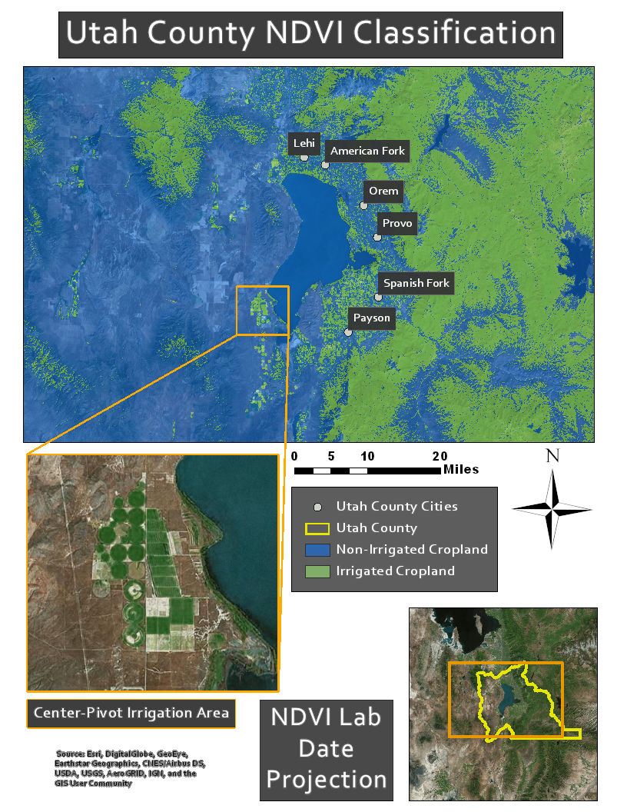

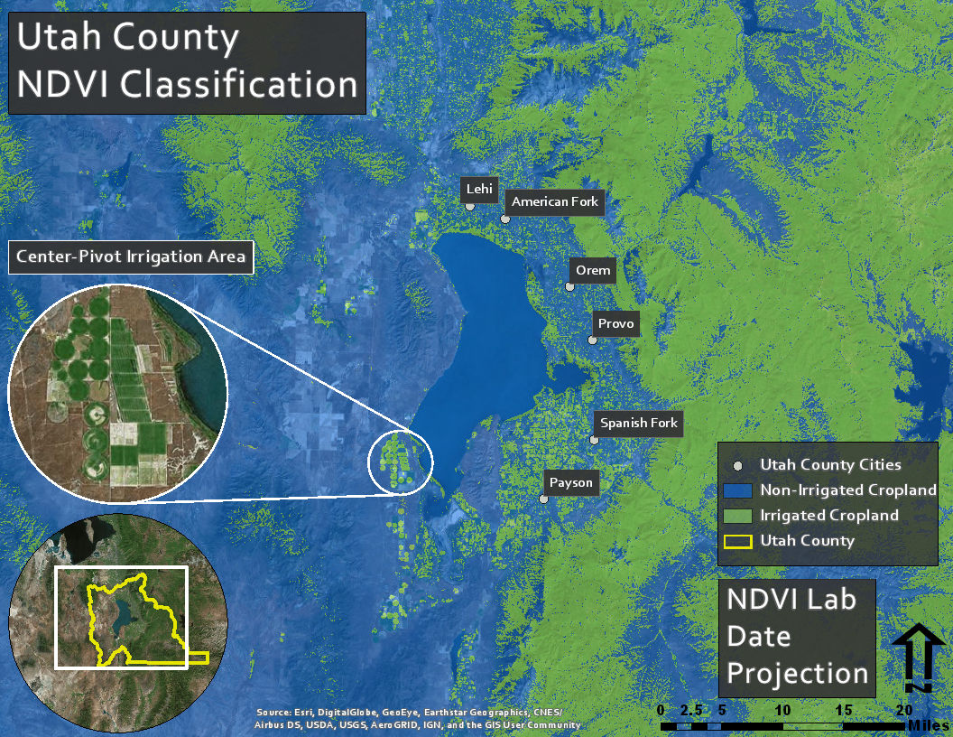

## Rubric for Classifying Land based on the NDVI

|  |  |
| --- | --- |
| **Item** | **Points** |
| Assignment Title, Name, Date, Course | /1 |
| Brief report on the requirements of the project | /5 |
| Describe your model   * List each of the tools used: (1 pt.) * List tool settings applied for the analysis (could someone repeat the lab using your report?): (1 pt.) * List all input, intermediate, and output datasets: (1 pt.) * Describe each input dataset including type (point, line, polygon, raster) and the source of the data: (1 pt.) * Describe each output dataset (point, line, polygon, raster): (1 pt.) | /5 |
| * One or more full pages (8.5 x 11) showing your model (5 pts.) * All text is readable (10pt. font minimum) (2 pts.) * All tools and data sets are shown (2 pts.) | /9 |
| * What locations within Utah County are most irrigated? (3 pts.) * Are your results as expected or did you find anything interesting or different than expected? (2 pts.) | /5 |
| Make a full page (8.5 x 11) map showing the results of your NDVI classification for Utah County.   * Map Title: (1 pt.) * Neat Line: (1 pt.) * North Arrow: (1 pt.) * Scale Bar: (1 pt.) * Text box with author name, date, map projection: (1 pt.) * NDVI classification image: (5 pts.) * Irrigated land versus non-irrigated land clearly symbolized: (1 pt.) * Polygon of Utah County: (1 pt.) * Labeled points indicating locations of a few large cities: (1 pt.) * Zoomed to an appropriate scale for viewing analysis results: (1 pt.) * All text is legible on printed map: (1 pt.) | /15 |
| * Create a Toolbox Interface for your model and include a screen capture of it including input and output data parameters. | 10 |
| **Bonus Task:** Repeat the lab exercise with a different dataset. Include in your report what data you used, how you acquired it, and what you may have changed to complete the exercise. Include an additional full-page map showing your results. | Instructor’s  Discretion |